The Graph of y = (-2)^{x}
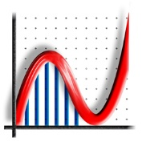

by Philip Lloyd

If we just choose INTEGER values of x we get the following points:
eg (0, 1), (1, –2), (2, 4), (3, –8), (4, –16) ... and (–1, – ½ ), (–2, ¼ ), (–3, –⅛)...

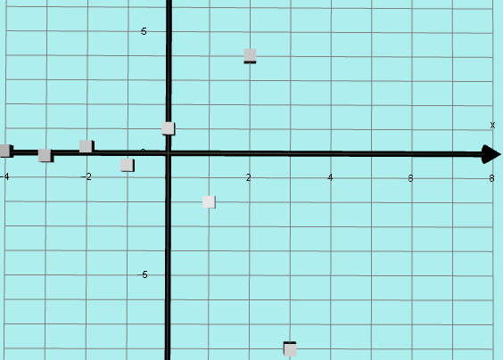
However, the graph does not just exist as a set of these isolated points.

If we choose x = 0.25 we get y = 0.84+ 0.84i
x = 0.5 we get y = 0 + 1.41i
x = 0.75 we get y = –1.19 + 1.19i
x = 1.25 we get y = –1.68 – 1.68i
x = 1.5 we get y = 0 – 2.83i
x = 1.75 we get y = 2.38 – 1.38i
x = –0.25 then y = 0.59 – 0.59i
x = –0.5 then y = 0 – 0.71i
x = –0.75 then y = –0.59 – 0.59i
x = –1.25 then y = –0.3 + 0.3i
x = –1.5 then y = 0 + 0.35i
x = –1.75 then y = 0.2 + 0,2i
etc
These points have a REAL PART and an IMAGINARY PART. In order to make sense of this, we need to be able to plot these complex y values so we need another axis besides the normal x and y axes.
I will use only REAL x VALUES on the x axis and in order to plot points such as
y = 0.2 + 0,2i I will put the real part on the normal y axis
and the imaginary part on the z axis (imaginary y axis), using Autograph.
The DOMAIN of this graph is all the real numbers (ie on the real x axis).
But instead of a simple y AXIS we now have a complex y PLANE.
I plotted the POINTS listed above and several more and produced this spiral.
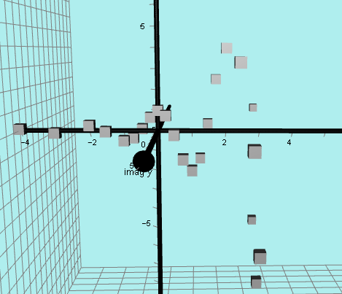

I then found the equation of the curve and the shape becomes clearer.
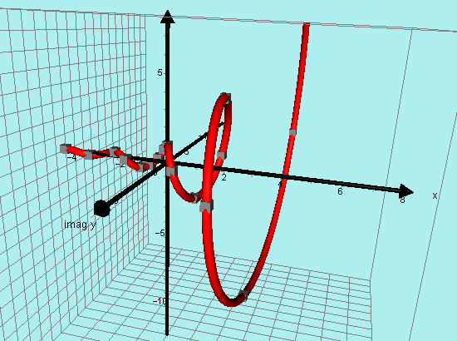

Here is another version without the extra “points” y = ( –2)^{x}
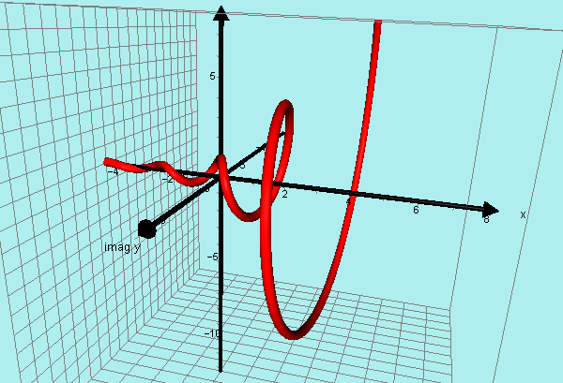

An interesting variation is to change the base of the equation to y = ( –1.25)^{x}
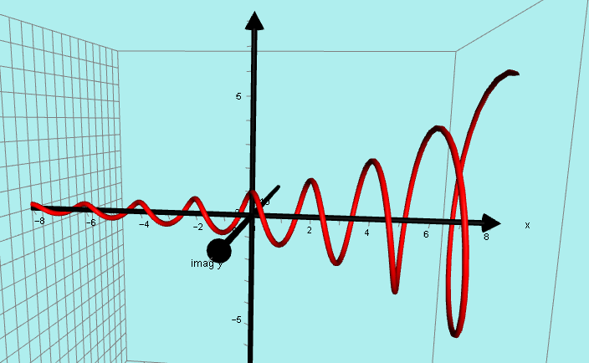
Auckland, February 2016

